Savescumming Combo Guide
By @xyntercept and @key7053
(thanks to Fishman and Alephcomputer for making the old version of this guide)

This guide is a revamp of an older guide.

This guide is for click combos involving save scumming and use of the FtHoF Planner. If you do not use these, please refer to this guide instead.

Game stages
This guide is specifically for late midgame and beyond. If you do not yet have 1 septendecillion cookies baked, please refer to this guide instead. Past this point, I’ve divided finnless combos into three stages:
- Lategame
  - Cookies baked: under 1 trevigintillion
- Endgame
  - Cookies baked: 1 trevigintillion to 1 octovigintillion
- Post-endgame
  - Cookies baked: 1 octovigintillion and higher
This guide will go into detail on all three stages, but note that combos from each stage still do share a lot of similarities, often building off of ideas from previous stages.

Glossary
Effects:
F - Frenzy
DH - Dragon Harvest
BS - Building Special
DF - Dragonflight
CF - Click Frenzy
EF - Elder Frenzy

Spells:
FtHoF - Force the Hand of Fate
GFD - Gambler’s Fever Dream

This guide will try to avoid acronyms other than these. If other acronyms need to be used for the sake of brevity, they will be explained.

Other Tips
These tips don’t really fit anywhere else but are useful to know.
- You can use enter instead of clicking the confirm button on most confirmation screens.
- If you enable screen reader mode, you can click a building and then hold enter to repeatedly buy it. This is particularly useful while doing Elder Battilion Rebuy, where you sell buildings for godzamok and rebuy them during the same godzamok buff with elder battalion slotted.
- You can alternate click+enter with screen reader on to precisely buy and sell buildings faster. For example, if you are buying 8 buildings, you could alternate click+enter 4 times, which is easier to mentally count and faster to perform than 8 individual clicks.
- Having a high wizard tower count whenever BSes are clicked will prevent a weak wizard tower BS.
- To prevent duplicate BSes in combos with many BSes in one savestate, you can sell the buildings whose BSes you have. Make sure to buy them back later, and note that this should typically not be done if it cuts into your click time.
- It is finnless legal to import from steam to web, but not in reverse, since steam is on v2.053 but web is on v2.058, and it is illegal to downgrade version on the leaderboards.
- If you play on a Mac, any shortcuts involving ctrl will not work since ctrl+click performs a right click. You can load this mod to replace all ctrl hotkeys with option: Game.LoadMod('https://yeetdragon24.github.io/ccmods/macCtrlFix.js')
- To avoid having to load mods whenever you open the game, you can use Cookie Clicker Mod Manager. You can get in on Chrome here or on Firefox here.

Lategame
At this point, you are likely familiar with at least the F+BS+CF combo. Combos at this stage are generally built off of this combo, typically with a Dragon Harvest and a couple more BSes added on top. The combo to get you to trevigintillions will likely be F+DH+4BS+CF or F+DH+3BS+EF+CF.

Why those combos specifically? Both of those come from quadcasts. A quadcast is any combo in which Force the Hand of Fate (FtHoF) is cast 4 times: dualcast, refill with a lump, dualcast again. Neither Gambler’s Fever Dream nor Caramelized Lumps are needed, making them rather simple. Here is an example of what a quadcast may look like in the FtHoF planner:
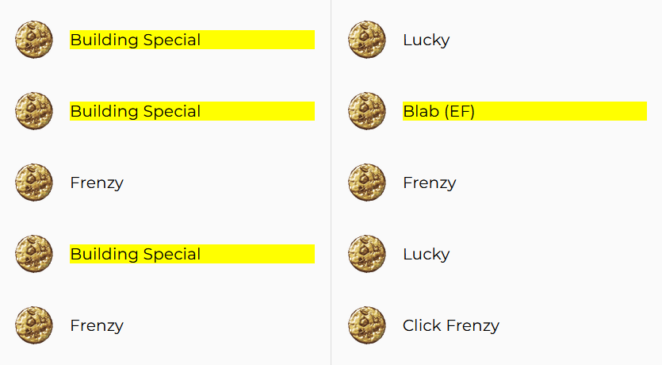
The useless middle spell can be skipped with a cheap spell like Haggler’s Charm (or Stretch Time if you want the extra buff time), so with proper season swaps, this could yield 3BS+CF. These effects would be cast on top of a base of F+DH+BS, which you can get through multitabbing.

At this stage, the garden doesn’t need to be used for golden cookie frequency: multitabbing alone is enough. Instead, it will only be used for extra cookies, with a full garden of whiskerblooms. If you have not unlocked whiskerblooms and cannot be bothered to do so, you may use thumbcorn for a smaller buff.

Here is precisely how to hit such a combo:

Setup
  - Ascend and check the planner to see if there is a quadcast soon (within ~30 spells). If there is, proceed.
  - Buy Heavenly Chip Secret then buy 100s of buildings and upgrades.
  - Sell most of your buildings except a farm, and plant the garden fully with whiskerblooms (or thumbcorn if whiskerblooms are not possible). When they mature, set the garden to clay and freeze it.
  - Upgrade your stock market office.
  - Set your pantheon to Nothing / Selebrak / Muridal (don’t go below 2/3 swaps).
  - Set Krumblor’s auras to Mind Over Matter and Reality Bending.
  - Get all upgrades from all seasonals.
    - Buy the Valentine’s Day Cookies.
    - Buy the Santa upgrades, and click as many reindeer as possible before you are able to start the grandmapocalypse (optionally through multitabbing).
    - Once you start the grandmapocalypse, get the Halloween cookies. You can save scum to speed this up.
    - While still in the grandmapocalypse, switch to Easter, then slot Dragon Orbs and save scum until it gives you a cookie storm. Use this to get all the Easter eggs, but do not buy Chocolate Egg. Instead, vault it to use later.
    - Switch to Christmas for a second time to clear out the reindeer cookies. If you want to speed it up, you could multitab by opening several tabs at once, and importing to all the tabs whenever you get a reindeer cookie.
  - Finish getting all the fortunes. Multitabbing can also be used here, although all tabs must be visible since fortunes have no audio cue. Since you’re not fortune scumming at this stage, it doesn’t matter much if you get the “Today is your lucky day!” fortune, but if you don’t get it, you may be able to get an extra onscreen golden cookie in your combo.
  - Perform a rudimentary setup combo of F+BS+CF to get building counts up.
    - Slot Godzamok into the diamond slot, and slot.
    - Before your main combo, find a CF in planner.
    - Get a natural frenzy, export save and import your save onto several tabs.
    - Get a natural building special on the next gc, and import save if you fail on all tabs.
    - Cast the CF.
    - Click the cookie a few times to afford the Golden Switch, then enable it.
    - Swap Krumblor’s Auras to Radiant Appetite and Breath of Milk or Elder Batallion and Radient Appetite.
    - Sell buildings for Godzamok and click the cookie.
    - Once you are done, slot Vomitrax into the diamond slot.
Note that also you can go for a smaller setup combo like F+DF gotten entirely through naturals, and execute the rest of the combo without Vomitrax if you want to save some time.
  - Skip spells to get to your quadcast. You shouldn’t need to skip many, so learning GFD Skip Skip isn’t especially important. If you want to, you may learn it here, but if you do not, you may use regular GFD skip. To skip a spell,
    - Cast Gambler’s Fever Dream.
    - Before it casts the spell it chooses, press ctrl+S to save the game.
    - Reload the game.
  - Set Krumblor’s auras to Epoch Manipulator and Arcane Aura.
  - In options, enable Fast Notes and disable Lump Confirmation. (this isn’t required, but it makes execution less annoying).

Multitabbing
  - Make sure that the Golden Cookie Alert Sound and Elder Pledge are enabled and export your save.
  - Open up several tabs (at least 10, preferably closer to 20 if your device can handle it).
  - If you hear the alert sound, check which tab it came from and click the golden cookie. You may use ctrl+tab and ctrl+shift+tab to navigate tabs more easily.
  - If you get a frenzy on any tab, export the save on that tab and import it to all others.
  - Repeat steps C and D until the frenzy is 7-10 minutes long. Note that the frenzy’s length will not visually update until you reimport the save.
  - Swap out Arcane Aura for Reaper of Fields.
  - Repeat steps C and D but for dragon harvest instead of frenzy until you get it 2 times in total.
  - Repeat step C to get a building special.
  - Swap Krumblor’s auras to Radiant Appetite and Breath of Milk, or if grimoire execution calls for it, Supreme Intellect and Reality Bending.
  - Export your save.

Execution
  - Import your final save from the multitabbing stage. You only need one tab open now.
  - Enable elder pledge if it has run out.
  - Cast your 4 grimoire buffs according to your route. Click the building specials, but leave click frenzy or elder frenzy on screen if possible. If you get a duplicate building special, go back to step A.
  - Enable the golden switch and sugar frenzy.
  - Unfreeze your garden.
  - If not already slotted, swap Krumblor’s auras to Radiant Appetite and Breath of Milk or Radient Appetite and Elder Batallion.
  - Take out all three loans, then mute banks.
  - Click any remaining FtHoF golden cookies.
  - Slot Godzamok into the diamond slot and Holobore into the ruby slot.
  - Sell all of your buildings from farms to antimatter condensers, except temples and time machines.
  - Slot Mokalsium into the diamond slot.
  - Turn on your autoclicker and hover on the cookie.
  - Once the effects begin to run out, purchase the Chocolate Egg.

Endgame
At this point, you have earned the final Cookies Baked achievement in the game. Combos at this stage will have one crucial difference from the previous stage, which is the addition of dragonflight. Using a specific garden setup, you can get four natural golden cookies, the last of which will be a dragonflight.

Some larger casts may also require the use of a caramelized sugar lump. To make the most of these combos, some more advanced execution tricks will also be included to prepare you for execution in the post-endgame level.

The combos in this stage are modified grails (F+DH+BS+DF+CF+EF), typically with a few extra building specials and sometimes missing an EF. The grimoire casts to get these combos typically range from quincasts to octocasts, with septcasts and octocasts typically requiring a caramelized sugar lump.

Finding routes for these combos will prove more difficult than quadcasts. The routes will require the use of Gambler’s Fever Dream for additional FtHoF casts. A very useful resource for calculating casts is Cursedsliver’s Grimoire Calculator. Use the arbitrary multicast section to put in your route and it will give you tower counts. However, it cannot calculate refills, so you’ll have to split your route up first. Another useful resource for routing (and for the FtHoF Planner in general) is the Finnless Grimoire Guide.

If you are using a caramelized lump, make sure you route click frenzy before the caramelized lump is used, since FtHoF cannot provide CF if there is an active DF buff. This is one of the three features Orteil added to prevent DF+CF stacking. They are:
- FtHoF cannot provide CF if there is an active DF buff
- Natural CF odds are reduced by 95% if there is an active DF buff
- Obtaining DF during a CF has an 80% chance to instantly end the CF (known as an “override”)
The easiest way to get it is to spawn a CF from grimoire, wait for a natural and click it for DF, then click the CF.

If you are doing an octocast, you will likely need a caramelized sugar lump. To get this, you can use the Choose Your Own Lump (CYOL) mod. This mod is like the FtHoF planner but for sugar lumps, since sugar lump type is seeded based on the millisecond in which the previous lump is harvested. By changing factors such as the number of grandmas and dragon auras, you can guarantee any sugar lump type. Simply configure your game correctly, export your save, and reimport once your current lump falls.

Cookies baked all time | What seed you should look for
Trevigintillions | Quincast - Sexcast (without cara)
Quattuorvigintillions | Quincast - Sexcast (without cara)
Quinvigintillions | Sexcast or Octocast
Sexvigintillions | Octocast
Septvigintillions | Octocast

Note: It is not recommended to do a septcast since it is considered a waste of a caramelized lump.

One more thing: at this stage, you will want to incorporate the garden into your combos. To get 4 natural golden cookies, you will need a setup like this:
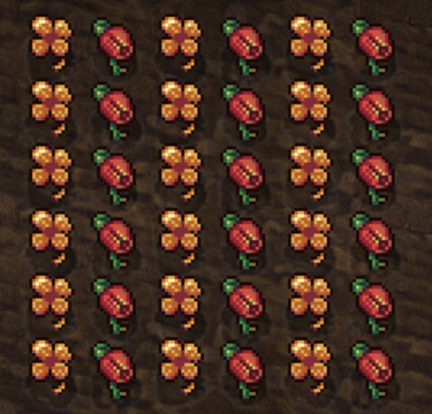
Note: the orientation of this setup does not matter.

During execution, you will replant to make one of these setups:
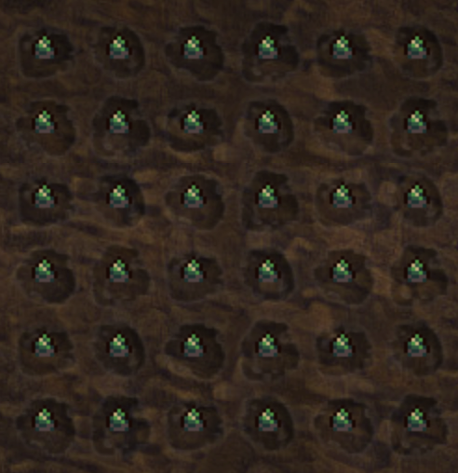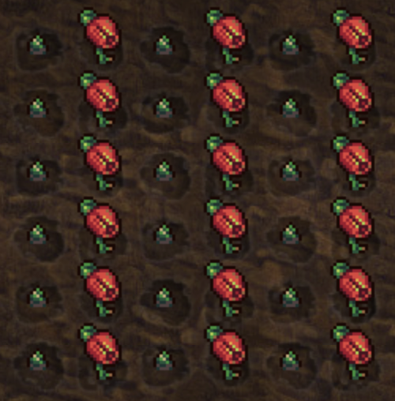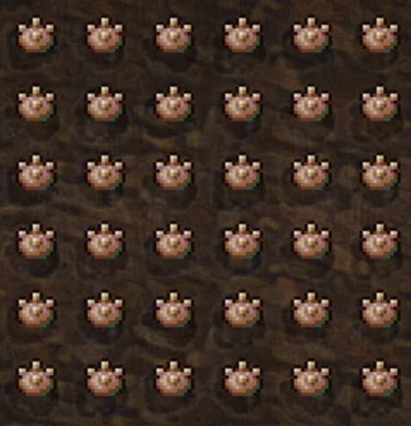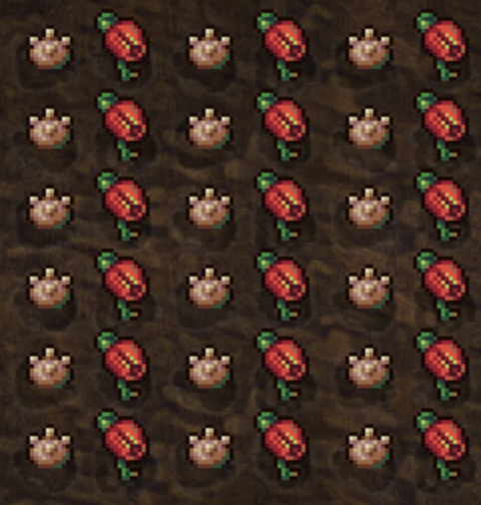
These replants are arranged from weakest to strongest. To make the plants mature, you will use a strategy called offline ticking, which takes advantage of the fact that the tick timer counts down offline. It will be touched on more later.
The first two setups require only 3 offline ticks, while the last two require 17 since whiskerblooms take much longer to mature. Each offline tick takes a minimum of one frame, so keep in mind that if you’re using a whiskerbloom setup, you will lose a minimum of 17 frames, or ~0.57 seconds, on all of your effects. Thus, if you know you will be very tight on execution time, that time may matter and it may be wise to use a thumbcorn setup instead.
Additionally, if any nursetulips will die within 17 ticks, the last setup may not be doable since the nursetulip will begin to die before the whiskerblooms are mature. If you choose a whiskerbloom setup, you must be very careful to control your nursetulips’ maturation times (via save scumming) to make them mature as close as possible to one another.
Lastly, it should be noted that offline ticking should ideally occur on fertilizer and then later in the combo you would swap to clay (the soil swap timer ticks down offline).

Here is precisely how to perform such a combo:

Setup
  - Ascend and check the planner to see if there is a cast you are looking for soon (within ~200 spells). If there is, find a route for it and proceed.
  - Buy Heavenly Chip Secret then buy 100s of buildings and upgrades.
  - Sell all your buildings except a farm, and plant the garden fully with alternating rows of golden clovers and nursetulips. When they mature, set the garden to clay and freeze it. Do not use Supreme Intellect as this effects growth inconsistency.
  - Upgrade your stock market office.
  - Set your pantheon to one of the two:
    - Nothing / Selebrak / Cyclius (if playing at 06:00 UTC+0 is convenient)
    - Nothing / Selebrak / Muridal (if playing at 06:00 UTC+0 is not convenient)
  - Set Krumblor’s auras to Mind Over Matter and Reality Bending.
  - Get all upgrades from all seasonals.
    - Buy the Valentine’s Day Cookies.
    - Buy the Santa upgrades, and click as many reindeer as possible before you are able to start the grandmapocalypse.
    - Once you start the grandmapocalypse, get the Halloween cookies. You can save scum to speed this up.
    - While still in the grandmapocalypse, switch to Easter, then slot Dragon Orbs and save scum until it gives you a cookie storm. Use this to get all the Easter eggs, but do not buy Chocolate Egg. Instead, vault it to use later.
    - Switch to Christmas for a second time to clear out the reindeer cookies. If you want to speed it up, you could multitab by opening several tabs at once, and importing to all the tabs whenever you get a reindeer cookie.
  - Finish getting all the fortunes. Multitabbing can also be used here, although all tabs must be visible since fortunes have no audio cue. Since you’re likely not fortune scumming at this stage, it doesn’t matter much if you get the “Today is your lucky day!” fortune, but if you don’t get it, you may be able to get an extra onscreen in your combo.
  - Perform a setup combo. It will need to provide enough cookies for you to replant your garden and buy golden switch with the frenzy, dragon harvest, and building specials of your combo active. For larger combos, the main purpose of a setup combo is to get stronger building specials. You will also need to be able to afford enough wizard towers for your grimoire route.
    - Slot Godzamok into the diamond slot.
    - Find and route the largest combo in the planner that is before your main combo.
    - Multitab to get F+DH+BS naturally.
    - Enable the golden switch, then cast your setup combo’s route.
    - Swap Krumblor’s Auras to Radiant Appetite and Breath of Milk.
    - Sell buildings for Godzamok (optionally swap in Mokalsium if you’re fine waiting the extra hour) and click the cookie.
    - Once you are done, slot Vomitrax into the diamond slot.
  - Skip spells to get to your combo. You should probably learn GFD Skip Skip now. If that guide is too confusing, there is a simpler instruction-based guide in the GFD Skip Skip section of this guide.
  - Use CYOL to get a golden sugar lump. Harvest it to get Sugar Blessing.
  - Use CYOL to get a caramelized sugar lump if you need it for your route.
  - Set Krumblor’s auras to Epoch Manipulator and Arcane Aura.
  - In options, enable Fast Notes and disable Lump Confirmation. (this isn’t required, but it makes execution less annoying)

Multitabbing
  - Make sure that the Golden Cookie Alert Sound and Elder Pledge are enabled and export your save.
  - Open up several tabs (at least 10, preferably closer to 20 if your device can handle it).
  - If you hear the alert sound, check which tab it came from and click the golden cookie. You may use ctrl+tab and ctrl+shift+tab to navigate tabs more easily.
  - If you get a frenzy on any tab, export the save on that tab and import it to all others.
  - Repeat steps C and D until the frenzy is 15-20 minutes long. Note that the frenzy’s length will not visually update until you reimport the save. The longer of a DH you want, the longer of a frenzy you will need.
  - Swap out Arcane Aura for Reaper of Fields.
  - Repeat steps C and D but for dragon harvest instead of frenzy until your dragon harvest is 5-10 minutes long.
  - Swap auras to Supreme Intellect and Reality Bending.
  - Export your save.

Initial Execution
  - Import your final save from multitabbing into all other tabs.
  - Configure each tab in the following way:
    - Enable elder pledge if it has run out.
    - Unfreeze garden.
    - Select the seed that will be used for planting.
    - Switch the building store to sell 100 (or whatever will be needed first for grimioire).
    - Make sure the proper season is enabled for the start of your grimoire execution (No season for No Change, and Easter for One Change)
    - Open Krumblor’s menu.
  - If you hear the alert sound, check which tab it came from and click the golden cookie.
  - If you get a building special on any tab, proceed with execution. If any effect is close to running out, reimport the last multitabbing save and reconfigure that tab.
  - Harvest all (or just all golden clovers) and plant your desired garden setup. Swap to fertiliser for faster offline ticking.
  - Cast your grimoire route. If a caramelized sugar lump is needed, stop casting for now and proceed with execution. If a click frenzy has been cast, do not click it yet.
  - Swap an aura to dragonflight.
  - Wait for a natural golden cookie to appear.
  - Click the natural. If it is dragonflight, proceed with execution. If not, reimport the last multitabbing save and reconfigure the tab.
  - Activate the Golden Switch, the Sugar Frenzy, and all three loans, then mute banks.
  - Swap your dragon auras to a CpS-boosting setup. Set one aura to Radiant Appetite.
    - If you are rebuying buildings after Godzamok, set the other aura to Elder Battalion.
    - If you are not, set the other aura to Breath of Milk.
  - Click all remaining onscreen golden cookies and export your save.

Final Execution
Note: if you have Cyclius slotted, it is preferable to do this step as close to 06:00 in UTC+0 as possible.
  - Offline tick your garden.
    - Wait 3 minutes so that the garden ticks as soon as you import your save.
    - Open the options menu.
    - Use ctrl+o to import save, and press enter.
    - As quickly as possible (preferably only a couple frames), click the export save button.
    - Repeat i-iv until the plants are mature.
  - Wait for the caramelized lump to ripen or fall if necessary.
  - Import your save that was exported in the previous step. You only need one tab now.
  - Swap to clay soil.
  - If your garden still has nursetulips in it, shift+ctrl+click the nursetulip seed to harvest them all.
  - If you have more casts in grimoire, switch season and activate elder pledge if necessary.
  - If you have more casts in grimoire, do them now and click the golden cookies.
  - Slot Godzamok into diamond and Holobore into ruby.
  - Sell buildings to Godzamok:
    - If you are not rebuying, sell all of your buildings from farms to antimatter condensers, except temples and time machines.
    - If you are rebuying, sell as many buildings as you like, as long as you are able to rebuy them in time. You can use an autoclicker to buy them faster.
  - Slot Mokalsium into the diamond slot.
  - Turn on your autoclicker keybind and hover on the cookie.
  - Once the effects begin to run out, purchase the Chocolate Egg.

Post-endgame
At this point, you’ve surpassed 1 octovigintillion cookies and could likely reach top 10 on the leaderboard with one more combo. You will want to start fortune scumming now; it is worth your time. Combos of this caliber often contain offset abuse, which is a very difficult strategy that is often given its own savestate.

Combos still consist of modified grails. They involve seed scouting for long periods of time to find seeds with lots of casts: the largest seed ever found in finnless was a duodecacast with an EF. Once you pass octocasts, combo seeds start to get much rarer, so knowing how to route well is very important. I’d once again recommend checking out the Finnless Grimoire Guide and trying to get a grasp of the following strategies:
- All basic mechanics regarding GFD, backfires, etc.
- GFD Cancel
- GFD Offset
- GFD Conversion
- GFD Offset Abuse
- A basic familiarity with overflow magic and mid-GFD sell
Also, whenever possible, incorporate Stretch Time into your routes. Especially if you’re using offset abuse, combos will likely be very tight on time, and even one Stretch Time cast can give you several extra seconds of execution time.
Try to make things easiest for yourself when you make a route. Don’t sacrifice any effects, of course, but go for sell by 100 routes if possible. You can also play around with savestates to try to put the most difficult parts of your route (like offset abuse) into its own savestate, or into the beginning of a savestate. However, you need to have refilled your magic once before your caramelized lump is harvested.

Cookies baked all time | What seed you should look for
Octovigintillions | EFless Octocast or higher
Novemvigintillions | EF Octocast or higher
Trigintillions | EFless Novcast or higher
Untrigintillions | EFless Novcast or higher
Duotrigintillions | EF Novcast or higher
Tretrigintillions | EFless Decacast or higher
Quattuortrigintillions | EF Decacast or higher
Quintrigintillions | EFless Undecacast or higher
Sextrigintillions | EF Undecacast or higher

The biggest change between this section and the previous is the use of fortune scumming. This involves save scumming to get the “Today is your lucky day!” fortune message during a combo, which summons a golden cookie, from which you typically want a dragonflight. Alternatively, you can get a building special from fortune scumming, but this is not recommended because it requires getting DF early, which drastically reduces execution time. The only scenario in which you may want to get a BS fortune is if you need to get CF before fortune scumming and you are not adding an additional savestate (from offset abuse, for example).

If your route has an EF, it needs to be cast in the fortune scumming savestate or later. Its duration is too short otherwise. It is best to route the CF into this savestate as well, but not completely necessary.

You should try to do this replant. Make sure the nursetulips are as young as possible to ensure that they will live long enough to coexist with the whiskerblooms after they mature.

At this point, you probably know enough to make some decisions yourself. If you want to add in a small savestate somewhere else, and you’d still have enough execution time, feel free. A lot will depend on your grimoire route, so no two combos will look the same. That being said, I’ll still provide a list of instructions for precisely how to perform one of these combos:

Setup
  - Ascend and check the planner to see if there is a cast you are looking for soon (within ~2000 spells). If there is, find a route for it and proceed.
  - Buy Heavenly Chip Secret then buy 100s of buildings and upgrades.
  - Sell all your buildings except a farm, and plant the garden fully with alternating rows of golden clovers and nursetulips. When they mature, set the garden to clay and freeze it. Do not use Supreme Intellect as this effects growth inconsistency.
  - Upgrade your stock market office.
  - Set your pantheon to one of the two:
    - Nothing / Selebrak / Cyclius (if playing at 06:00 UTC+0 is convenient, should work unless you’re in South America or eastern North America)
    - Nothing / Selebrak / Muridal (if playing at 06:00 UTC+0 is not convenient)
  - Set Krumblor’s auras to Mind Over Matter and Reality Bending.
  - Get all upgrades from all seasonals.
    - Buy the Valentine’s Day Cookies.
    - Buy the Santa upgrades, and click as many reindeer as possible before you are able to start the grandmapocalypse.
    - Once you start the grandmapocalypse, get the Halloween cookies. You can save scum to speed this up.
    - While still in the grandmapocalypse, switch to Easter, then slot Dragon Orbs and save scum until it gives you a cookie storm. Use this to get all the Easter eggs, but do not buy Chocolate Egg, instead vaulting it to use later.
    - Switch to Christmas for a second time to clear out the reindeer cookies. If you want to speed it up, you could multitab by opening several tabs at once, and importing to all the tabs whenever you get a reindeer cookie.
  - Finish getting all fortunes except the “Today is your lucky day!” fortune. You will need this for fortune scumming, and only one such fortune can be obtained per ascension. Get all others, including Lucky Numbers, to maximize the odds of this one during your combo.
  - Perform a setup combo. It will need to provide enough cookies for you to replant your garden and buy golden switch with the frenzy, dragon harvest, and building specials of your combo active. For larger combos, the main purpose of a setup combo is to get stronger building specials. You will also need to afford enough wizard towers for your grimoire route.
    - Slot Godzamok into the diamond slot.
    - Find and route the largest combo in the planner that is before your main combo.
    - Multitab to get F+DH+BS naturally. If the strongest available setup combo is weak, you could unfreeze your garden and scum for DF, but you will lose a tick on your plants. If this is a concern, replant afterwards.
    - Enable the golden switch, then cast your setup combo’s route.
    - Swap Krumblor’s Auras to Radiant Appetite and Breath of Milk.
    - Sell buildings for Godzamok and swap in Mokalsium.
    - Take out loan 2 only. You can take out loan 1 as well if you’d like, but remember you won’t be able to skip spells for 6 hours.
    - Click the cookie.
    - Once you are done, slot Vomitrax into the diamond slot.
  - Skip spells to get to your combo. Use GFD Skip Skip.
  - Find the longest streak of Shimmering Veil protects and get to the streak.
    - Open the Random Call Planner.
    - Use this script. There are instructions in the comment.
    - Once you know the location of the largest streak, use an autoclicker to get there. Once you are within a few hundred, click manually to make sure you don’t miss it.
  - Use CYOL to get a golden sugar lump. Harvest it to get Sugar Blessing.
  - Use CYOL to get a caramelized sugar lump if you need it for your route.
  - Set Krumblor’s auras to Epoch Manipulator and Arcane Aura.
  - In options, enable Fast Notes and disable Lump Confirmation. (this isn’t required, but it makes execution less annoying)

Multitabbing
  - Make sure that the Golden Cookie Alert Sound and Elder Pledge are enabled and export your save.
  - Open up several tabs (at least 10, preferably closer to 20 if your device can handle it).
  - If you hear the alert sound, check which tab it came from and click the golden cookie. You may use ctrl+tab and ctrl+shift+tab to navigate tabs more easily.
  - If you get a frenzy on any tab, export the save on that tab and import it to all others.
  - Repeat steps C and D until the frenzy is 15-20 minutes long. Note that the frenzy’s length will not visually update until you reimport the save. The longer of a DH you want, the longer of a frenzy you will need.
  - Swap out Arcane Aura for Reaper of Fields.
  - Repeat steps C and D but for dragon harvest instead of frenzy until your dragon harvest is 5-10 minutes long.
  - Swap out Reaper of Fields for Arcane Aura.
  - Export your save.

Initial Execution
  - Import your final save from multitabbing into all other tabs.
  - Configure each tab in the following way:
    - Enable elder pledge if it has run out.
    - Unfreeze garden.
    - Select the seed that will be used for planting.
    - Switch the building store to sell 100 (or whatever will be needed for grimioire).
    - Make sure the proper season is enabled (No season for No Change, and Easter for One Change. If execution time is tight, use Business Day, and switch seasons as necessary after you get the natural golden cookie.)
    - Open Krumblor’s menu.
  - If you hear the alert sound, check which tab it came from and click the golden cookie.
  - If you get a building special on any tab, proceed with execution. If any effect is close to running out, reimport the last multitabbing save and reconfigure that tab.
  - Harvest all (or just all golden clovers) and plant your desired garden setup. Swap to fertiliser here for faster offline ticking
  - Swap auras to Supreme Intellect and Reality Bending.
  - Cast the first part of your grimoire route. It is preferable that you get up to the point where you’d need a caramenlized lump, but if this is not possible, you need to at least pass the first refill.
  - If you have Manabloom, get your wizard tower count to whatever will be needed next for your route. If you don’t, get your wizard tower count as high as possible.
  - Sell some of the buildings tied to building specials you have. Do not sell any building with a minigame as you will need to access the minigame, and do not sell grandmas as the grandmapocalypse will restart when they are purchased again.
  - Wait for a natural golden cookie to appear.
  - Activate the Golden Switch, the Sugar Frenzy, and loans 1 and 3.
  - Click the natural. If it is a building special, proceed with execution. If not, reimport the last multitabbing save and reconfigure the tab.
  - If you haven’t already, get your wizard tower count to whatever will be needed next for your route.
  - Click all remaining onscreen golden cookies and export your save.

Fortune Scumming
  - Offline tick your garden.
    - Wait 3 minutes so that the garden ticks as soon as you import your save.
    - Open the options menu.
    - Press ctrl+o and paste in your save. Hover your cursor over the export save button.
    - Press enter and left click almost at the same time. The objective is to click export save within 1 frame of importing.
    - Open the save editor. You won’t be editing your save, just checking how many frames your offline tick took.
    - Open the buffs tab, click on any buff, and click “edit buff.” This should show the current number of frames remaining on the buff, which can be compared to your previous save to find the frames elapsed (ideally 1).
    - Repeat steps i-vi until the plants are mature.
  - If you need another savestate for offset abuse, do this savestate now (before your fortune scumming savestate) if possible.
  - Import your save from the previous savestate. It is best to do steps C-J in under 10 seconds, but this is very difficult and as long as you can do it in under 15 seconds you are probably fine.
  - Click the news ticker.
  - Swap to clay soil.
  - Enable a season if needed for casting.
  - Finish your grimoire route.
  - Swap godzamok into the diamond slot.
  - Take out loan 2 and mute banks.
  - Swap auras to Dragonflight and Radiant Appetite.
  - Buy back any buildings you sold earlier.
  - Open the options menu.
  - If a fortune has appeared, click it. If it doesn’t appear or doesn’t give a dragonflight, reimport the fortune scumming savestate.
  - Swap Dragonflight to Elder Battalion.
  - Click all other onscreens and export save.

Final Execution
  - Zoom out your tab so that all buildings can be visible at once in the store.
  - Import your save from the end of fortune scumming.
  - Shift+ctrl+click the nursetulip seed to harvest them all.
  - Slot Holobore into the ruby slot.
  - Activate the Shimmering Veil.
  - Switch the store to sell all.
  - Turn on your autoclicker, and, starting from You, move your cursor up your building list. Do this quickly, but still slow enough for no buildings to be skipped.
  - Switch the store to buy 100, enable your autoclicker, and, while holding shift, move your cursor down the building list. This will need to be a bit slower than the previous step to make sure the maximum of all buildings are purchased.
  - Swap Mokalsium into the diamond slot.
  - Turn on your autoclicker and hover on the cookie.
  - Once the effects begin to run out, purchase the Chocolate Egg.

